W1 PRACTICE

*MOBILE* ***USABILITY ANALYSIS***

In this practice, you will step into the shoes of a UX designer and critically evaluate a mobile application.

**Usability** and **design** are key factors that influence how users interact with an app, and understanding these aspects is essential for creating effective and enjoyable digital experiences.

## *Learning objectives*

* Recognize inefficiencies or potential **usability issues** in **user flows**
* Evaluate a mobile application based on **Nielsen’s 10 Usability Heuristics**
* Critically analyze the **app's design** strengths and weaknesses

## *How to submit?*

* Attach your **report t**o the MS Team assignment and **turn it in**

## *Some references about UX/UI!*

*USABILITY THEOERY*

[Jacob 10 heuristics](https://cadtedu-my.sharepoint.com/:b:/g/personal/cs_cadt_edu_kh/EbMqM-9HOndEvHHdRsyYtwQBn_ys_6mcYc8hqGz3w5-Nmg?e=wp5YaJ)

[Don’t Make Me Think Book](https://cadtedu-my.sharepoint.com/:b:/g/personal/cs_cadt_edu_kh/ESkDDKEr1S9ApwdT4B1Jf2wBKn97l8hZ86mj-4Vg7w2TbQ?e=Ipug8H)

[Introduction To Usability](https://www.nngroup.com/articles/usability-101-introduction-to-usability/)

<https://www.kickassux.com/ux-library/ux-process>

*CASE STUDY EXAMPLES*

[Kotak Case Study](https://www.behance.net/gallery/128771067/HEURISTICS-EVALUATION-OF-KOTAK-811-MOBILE-APP?tracking_source=search_projects|heuristics+evaluation+mobile+app&l=7)

[ContractCar Case Study](https://www.behance.net/gallery/154601207/Contactcars-(-heuristics-evaluations-)?tracking_source=search_projects|heuristics+evaluation+mobile+app&l=3)

#### STEP 1 –APP SELECTION & INSTALLATION

Select and install an existing mobile application.

**WARNING:** Choose an application related to 1 of following business types:

* **Transportation app** *(ex: Grab or BookMeBus)*
* **Food Delivery app** *(ex: Delishop, NHAM24)*

|  |  |
| --- | --- |
| App Name | *Grab* |
| Business Type | Transportation app |

#### STEP2 – TASK SELECTION

Identify a relevant task on the application.

**WARNING:** The task should be **complex enough** (take multiple steps to complete)

|  |  |
| --- | --- |
| Task | Book a Tuk-Tuk from my place to CADT |
| Targeted user | Grab is for everyone, especially students, teachers, and staff. |
| Frequency | This task is done every day, sometimes many times a day, especially during busy hours when people need a ride or order food. |
| Importance | *Select the relevant option*:   * **The task is essential for the primary purpose of the application** (Booking a ride it is a core function of the Grab app) |

#### STEP 3 – USER FLOW TO PERFORM THE TASK

Write the user flow (sequence of low-definition wireframes) to complete the chosen task.

 [How to write a user flow?](https://www.youtube.com/watch?v=KYLvmxcWcEA)

INSERT FIGMA LINK or SNAPSHOT HERE

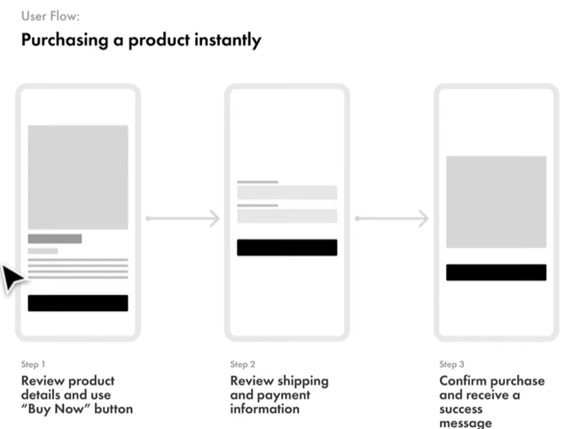

*The user flow investigates the actions required by a user to complete the task.*

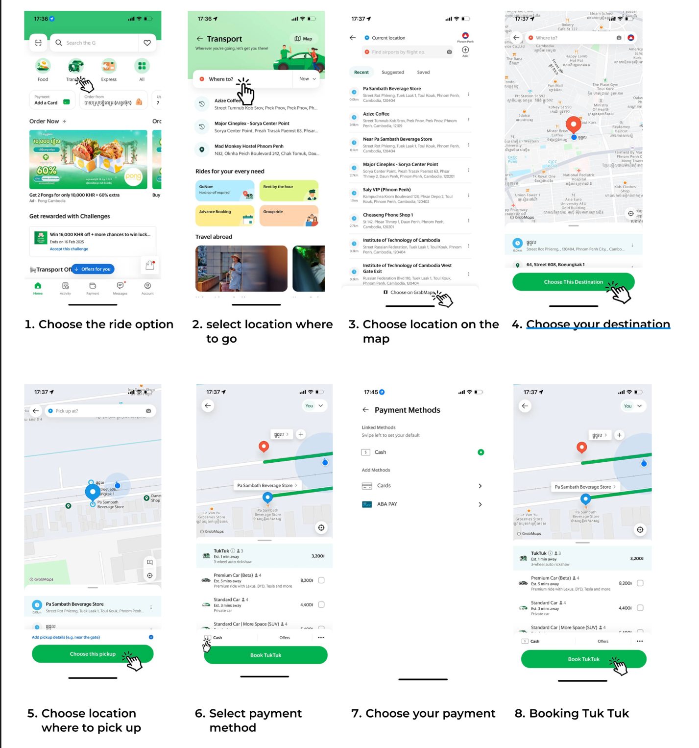

Analyze the user flow

* Is the **user flow intuitive** and easy to follow for a first-time user?
* Are there **unnecessary** steps or redundant actions in the process?
* Are there points in the flow where the user **might feel confused** or encounter difficulties?
* **Yes, the Grab app is designed to be simple and clear, even for first-time users. The layout is straightforward, and users can easily find the options they need.**
* For example, in the **payment process**, users sometimes have to confirm payment details multiple times (once when selecting the payment method and again when confirming the order).
* Using different button shapes, like one rectangle and one with rounded corners, makes the design look messy and may confuse users.
* A screenshot of a map

  Description automatically generatedA screenshot of a phone

  Description automatically generatedIf the app uses different terms for similar actions (e.g., "Booking Tuk Tuk" for rides and "Place order " for food), users may get confused about what these terms mean.

How **many steps** are needed to complete this task?

Do you think the **user** **flow** is relevant, regarding the **importance and the frequency** of this task?

* **For ride booking:**

1. Open the Grab app.
2. Choose the ride option (e.g., car, tuk-tuk).
3. Set the pick-up location (either by entering an address or selecting from the map).
4. Set the drop-off location (CADT or another destination).
5. Confirm the ride details (check pricing, time, etc.).
6. Select payment method (e.g., cash, ABA).
7. Book the ride (tap “Booking Tuk Tuk”).

* For Food Delivery:

1. Open the Grab app.
2. Select the restaurant or item you want to order.
3. Set the delivery address.
4. Add items to cart.
5. Confirm the order and payment method.
6. Place the order.

#### STEP 4 – USABILITY HEURISTICS

Apply recognized usability principles, such as [Nielsen’s 10 Usability Heuristics](https://cadtedu-my.sharepoint.com/:b:/g/personal/cs_cadt_edu_kh/EbMqM-9HOndEvHHdRsyYtwQBn_ys_6mcYc8hqGz3w5-Nmg?e=wp5YaJ), to identify potential issues.

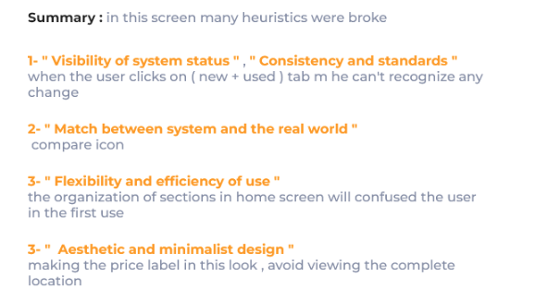

**To guide your analysis**:

* See below the check list points for each heuristic
* You can also get inspirations on other case studies:
  + [Kotak Case Study](https://www.behance.net/gallery/128771067/HEURISTICS-EVALUATION-OF-KOTAK-811-MOBILE-APP?tracking_source=search_projects|heuristics+evaluation+mobile+app&l=7)
  + [ContractCar Case Study](https://www.behance.net/gallery/154601207/Contactcars-(-heuristics-evaluations-)?tracking_source=search_projects|heuristics+evaluation+mobile+app&l=3)

**WARNING:** You need to identify at **least 3 relevant UX/UI issues** and refer to the right Heuristic.

|  |  |
| --- | --- |
| Usability issue | Inconsistent Button Labels (e.g., "Booking Tuk Tuk" vs. "Place Order"). |
| Related Heuristic | Consistency and Standards |
| Proposed remedial (optional) |  |

|  |  |
| --- | --- |
| Usability issue | Lack of Clear Error Messaging or Alert |
| Related Heuristic | **Error Prevention** |
| Proposed remedial (optional) |  |

|  |  |
| --- | --- |
| Usability issue | Too Many Notifications |
| Related Heuristic | Minimalist Design |
| Proposed remedial (optional) |  |

#### STEP 5 – SUMMARIZE

- Highlight the **app’s strengths and weaknesses** based on your analysis.

**Strengths**  
-Grab has a simple and easy-to-use.

-Grab offers many different services to cater to various user needs. For example, Grab provides services like ride-hailing, food delivery,

**Weaknesses**

- Inconsistent Button Labels: action buttons (e.g., "Booking Tuk Tuk" for rides vs. "Place Order" for food delivery) can cause confusion.

- Suggest **specific improvements** to address identified issues.

Use a consistent label all confirmation buttons as "Confirm" or "Confirm Order" to avoid confusion.

#### APPENDIX – USABILITY HEURISTICS GUIDE (7)

|  |  |
| --- | --- |
| HEURISTIC | **Visibility of System Status** |
| GOAL | The design should always keep users informed about what is going on |
| CHECK LIST | Are system status **updates** (e.g., success or error) provided **in real-time**?  Is the user **informed of ongoing processes** (e.g., uploads, downloads, or syncing)?  Do icons, animations, or visual cues **provide feedback** for user interactions (e.g., button presses)?  Is there a clear **loading indicator** for actions like content loading? |

|  |  |
| --- | --- |
| HEURISTIC | **Match Between System and the Real World** |
| GOAL | The design should speak the users' language |
| CHECK LIST | Are labels, icons, and terminology **familiar** and aligned with the user’s expectations?  Is the user **familiar** with the terminology used in the design? |

|  |  |
| --- | --- |
| HEURISTIC | **User Control and Freedom** |
| GOAL | Users need a clearly marked way to leave unwanted action |
| CHECK LIST | Can users easily **undo actions**, such as deleting or modifying an entry?  Is it easy to **exit or abandon** tasks without unintended consequences?  Can users easily **interact with the inputs**, **buttons** using their **thumb** (mobile usage)? |

|  |  |
| --- | --- |
| HEURISTIC | **Consistency and Standards** |
| GOAL | Users should not have to wonder if different words, situations, actions mean the same thing. |
| CHECK LIST | Are design patterns (e.g., button styles, fonts, colors) **consistent across screens**?  Are standard **platform conventions** followed (e.g., iOS vs. Android design guidelines)?  Are icons**, gestures, and interactions** consistent throughout the app?  Do **repeated actions** **behave the same** way every time (e.g., swiping left to delete)?  Are similar features in the app named or **structured identically**? |

|  |  |
| --- | --- |
| HEURISTIC | **Error Prevention** |
| GOAL | Best designs carefully prevent problems from occurring in the first place. |
| CHECK LIST | Are potentially harmful actions (e.g., deleting an account) **confirmed** with a dialog or warning?  Are **inactive or disabled elements visually** distinct to prevent misuse?  Are actions **logically sequenced** to minimize mistakes (e.g., confirming details before proceeding)? |

|  |  |
| --- | --- |
| HEURISTIC | **Minimalist** |
| GOAL | Interfaces should not contain information that is **irrelevant** or rarely needed. |
| CHECK LIST | Are **primary actions prominently** displayed, with secondary options de-emphasized?  Are **visual hierarchies clear**, guiding users toward their goals efficiently  Are colors, fonts, and images used purposefully and consistently to **avoid distractions**?  Is **negative space** effectively used to improve readability and focus? |

|  |  |
| --- | --- |
| HEURISTIC | **Help Users Recognize, Diagnose, and Recover from Errors** |
| GOAL | Error messages should **indicate the problem**, and suggest a **solution** |
| CHECK LIST | Are **error messages clear**, specific, and written in plain language?  Do error messages suggest **actionable steps to** resolve the issue?  Is the error’s location **visually highlighted** for easy identification?  Are users notified of errors immediately and not after they’ve progressed further?  Can users easily **retry or correct** an action without starting over? |